|  |  |  |  |  |
| --- | --- | --- | --- | --- |
| Name: | ___________________________________________________ | | | Date: *___________* |
| pact jpg1 | **Subject: Year 11 Applications**  **Test 3, 2015**  **Topics – Matrices, Scale drawing and Similarity** | | | 55  = % |
| **Total Time:** | ***60*** *minutes* |  | | |
| **Total Reading:** | *5**minutes* |
| **Total Working:** | *55**minutes* |
| **Weighting:** | *10% of the year.* |
| **Equipment:** | *Curriculum Council Formula Sheet; ½ page notes (A4 one side), CAS calculator; Scientific Calculator* | | | |
|  | | | | |
| **SECTION 1: CALCULATOR FREE** | | | | |
| **Time:** | ***22*** *minutes* | **Marks for Section 1:** | *20* | |
| **Reading:** | *2**minutes* | **Equipment Allowed:** | *Nil* | |
| **Working:** | *20**minutes* |  |  | |

|  |  |
| --- | --- |
| **1.** | **[4 marks: 1 mark each]** |

Write the following scales as a ratio in its simplest form, without the units.

a) 5cm : 1m b) 2mm : 20m

c) 0.5cm : 4km d) 1m : 0.55km

|  |  |
| --- | --- |
| **2.** | **[1 mark]** |

Circle the correct answer.

What is the enlargement factor?

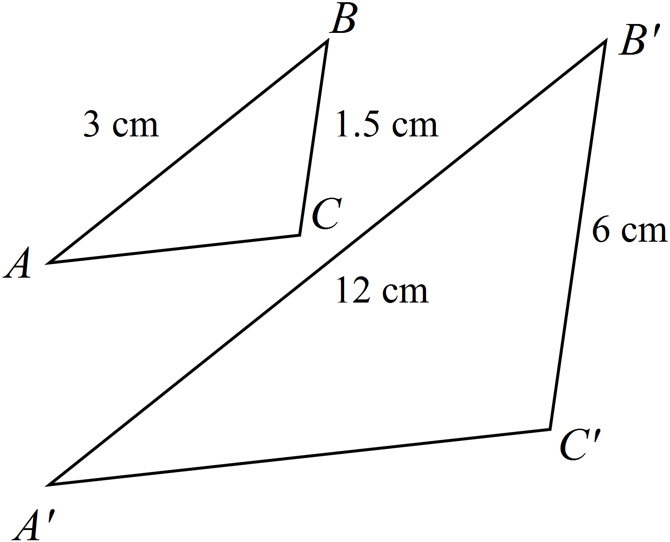

NOT TO

SCALE

|  |  |
| --- | --- |
| **3.** | **a) 2 b) 4 c) 3 d) 6**  **[1 mark]**  Circle the correct response. |
|  |

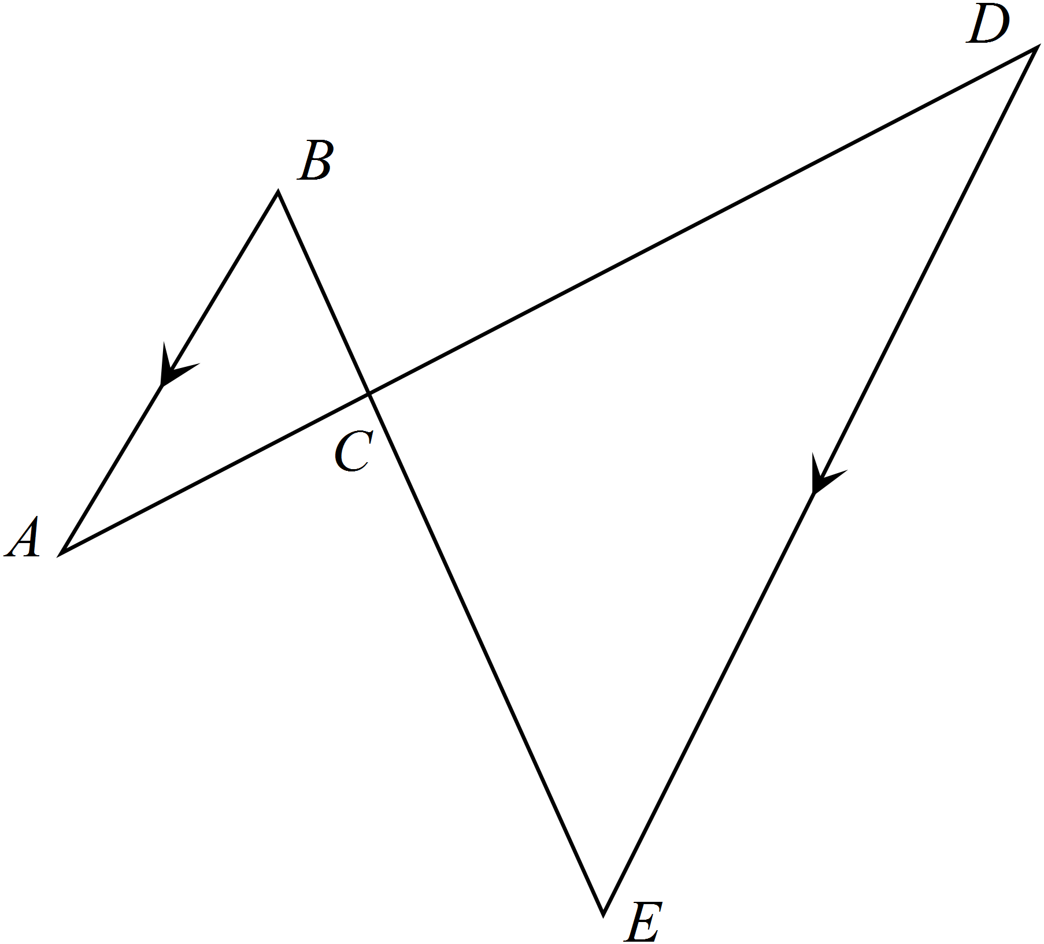

Which of the following reasons could be used to prove that?



a) The three corresponding sides of the triangles are in the same ratio.

b) The three corresponding angles of the triangles are in the same ratio

c) The three corresponding angles of the triangles are equal.

d) Two corresponding sides of the triangles are in the same ratio and the included angle is equal.

**4. [2 marks]**

Rebecca prints out a square photograph, then decides that she likes it so much she wants frame it. She

needs to enlarge the photo to four times the original size. If the area of the original photograph was

100 cm2. What is the area of the enlarged photograph?

**5. [4 marks; 1 mark each]**

Use Matrix A below to answer the following question;

Matrix A = 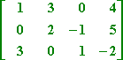

1. How many elements are there in Matrix A?
2. What is the order of Matrix A?
3. Is Matrix A a square matrix?
4. What is the value of element a13 ?

**6. [8 marks; 1,1,1,2, 3]**

Answer the following given that;



1. A + B
2. A – B
3. 2A
4. AB

e) 3A + AB

|  |  |  |  |  |
| --- | --- | --- | --- | --- |
| Name: | ___________________________________________________ | | | Date: *___________* |
| **SECTION 2: CALCULATOR ASSUMED** | | | | |
| **Time:** | ***38*** *minutes* | **Marks for Section 2:** | *35* | |
| **Reading:** | *3 minutes* | **Equipment Allowed:** | *½ page notes (A4 one side),*  *CAS calculator* | |
| **Working:** | *35**minutes* |  |  | |

**7. [8 marks: 2, 2, 2, 2]**

Use the matrices below to answer the following matrix calculations if they are possible;

A = $\left[\begin{matrix}-15 & 6 \\ 8 & 21\end{matrix}\right]$ B = $\left[\begin{matrix}0.5 & -1.6 \\ 2.3 & 10.2\end{matrix}\right]$ C = D =

1. AD
2. 2B2
3. 4A + B
4. 2CD

**8. [2 marks]**

Two rectangles are similar. The smaller rectangle has sides 12 cm and 7 cm. The longer side of

the larger rectangle is 30 cm. How long is it’s shorter side? (Hint: Draw a diagram)

**9. [2marks]**

The plan of a building is drawn to a ratio of 1:20. If the width of the building on the plan is 205 cm,

what is the width of the actual building?

**10. [4 marks: 1, 1, 2]**

Use the Diagrams below to answer the following questions.

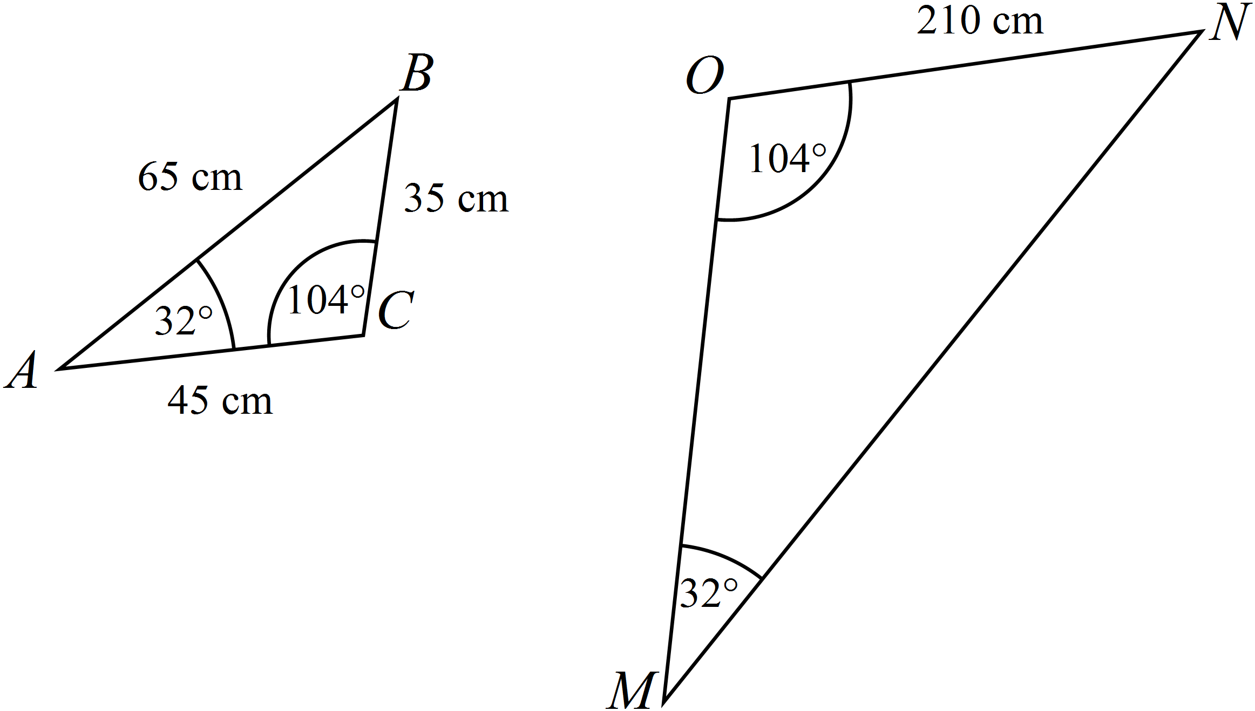

1. What similarity rule can be used to prove  is similar to ?
2. What scale factor was used to draw?
3. Given this scale factor, what are the lengths of the remaining two sides of ?

**10. [5 marks: 2, 1, 1, 1 ]**

The following table shows the number of first, second and third places that five competing

athletes gained, at a recent athletics carnival.

|  |  |  |  |
| --- | --- | --- | --- |
|  | 1st | 2nd | 3rd |
| Zane | 2 | 1 | 3 |
| Michael | 1 | 0 | 4 |
| Daniel | 0 | 5 | 2 |
| Matthew | 2 | 2 | 2 |
| Benjamin | 3 | 0 | 4 |

1. Construct a 5 x 3 matrix to represent these results and call it Matrix A.
2. If athletes were awarded 5 points for 1st place, 3 points for a 2nd place and 1 point for a 3rd place construct a 3 element column matrix and call it Matrix B.
3. Using the matrices A and B calculate the total points received by each athlete.
4. An award is given to the athlete who earns the most points during the meet. Who of the 5 athletes won the award?

**11. [8 marks: 2, 2, 4]**

Use the following floor plan to answer the questions below given that it has been drawn to the following scale 1: 150.

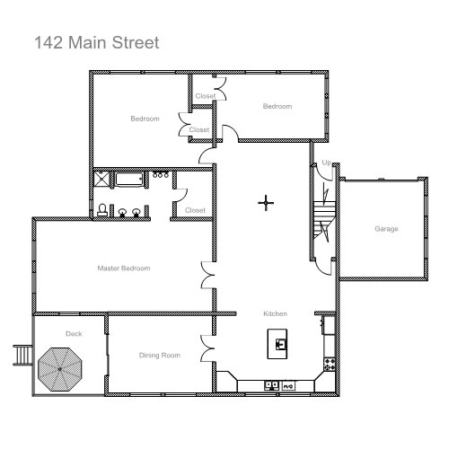

1. What are the dimensions of the garage?
2. What would be the area of the deck in real life?
3. If all of the bedrooms, including the closets, are to be carpeted, what is the total amount of carpet needed in square metres?

**12. [6 marks:4, 2]**

A child is playing in a sand pit and is using a small cube that is filled to the top with sand, to fill a larger cube. Given that the smaller cube has a side length of 10cm and the larger cube has a side length of 55cm;

1. How many times will he have to fill up the smaller cube in order to fill the larger cube with sand? (Hint: all regular solids are similar)
2. If the child now decides to fill the cubes with water, using the same process, will this change the number of times he has to fill the smaller cube? (explain your answer)

**~ END OF TEST SECTION 2 ~**